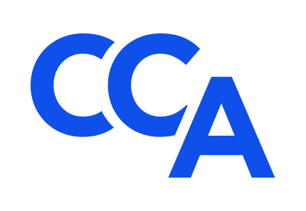
College of Commercial Arbitrators
Application for 2025-2027 Associates Mentorship Program
Submission Deadline: April 21, 2025
Applicant.
Name: ______________________________________________________________________
Employer: ___________________________________________________________________
Occupation: _________________________________ Title: __________________________
Address: ____________________________________________________________________
Email: ______________________________________ Phone: ________________________

Please submit the following information to support your application for Class No. Four of the CCA Associate Mentorship Program (Program) as outlined in the accompanying Invitation:
(1) a concise letter from you to the Program Co-Chairs that explains (a) the nature and extent of your prior experience serving as an arbitrator, mediator, special master, or administrative hearing officer in domestic and/or international commercial dispute resolution proceedings prior to and during the past five years, including the number and types of prior arbitration cases where you served as the sole arbitrator and/or as a panel member; (b) your reasons for applying or reapplying to participate in the Program; and (c) how you intend to develop the skills needed to distinguish yourself in the field of commercial arbitration;
(2) a resume of your education, training, and professional experience that (a) summarizes your credentials and qualifications for the Program; (b) highlights your areas of subject matter expertise; and (c) explains the likelihood of your future success as a commercial arbitrator; and
(3) two letters of recommendation in support of this application from Fellows or other ADR professionals with personal knowledge of your credentials, qualifications, character, talents, professionalism, and career goals.
Qualified non-attorneys are welcome to participate in the Program.
Schedule:
Application Process Opens: February 3, 2025.
Application Submission Deadline: April 21, 2025.
Applicant Interviews: Week of May 12, 2025.
Associate Selection Announcement: Week of June 23, 2025.
Mentor Selection Announcement: Week of July 21, 2025.
Initial Virtual Meeting with Associates and Mentors: September 8 – September 12, 2025 (TBD).
Second Virtual Meeting with Associates and Mentors: October 6 – October 10, 2025 (TBD).
CCA’s 25th Annual Meeting: October 22-25, 2025. Fellows and Associates only at Silverado Resort & Spa, Napa Valley, CA.
CCA’s 26th Annual Meeting: October 1-2, 2026. Fellows and Associates only in Chicago, IL.
Fellows, Mentors, and Associates will communicate regularly between annual meetings via bi-monthly Program meetings, periodic CCA committee meetings and events, and CCA listserv, and they will collaborate informally throughout the year with the view towards sharing professional experiences, business development ideas, and professional networks in a collegial manner that promotes a rewarding career in commercial arbitration.
Affirmation.
Applicant affirms that (A) all information submitted in support of your application is true, accurate, and complete to the best of your knowledge, information, and belief; (B) you are ready, willing, and able to attend CCA’s 25th and26th Annual Meetings in person (via the Tuition Waiver described in the accompanying Invitation) and actively participate in the Schedule of Events and other related CCA events; (C) you are not currently and have not previously been the subject of a professional disciplinary proceeding of any sort; and (D) it is your responsibility to promptly notify CCA and your Mentors in the event any of these circumstances change during your participation in this application process and Program.
Tuition Waiver.
Registration and other participation fees will be waived for all upcoming CCA events that are part of the Program, including the Annual Meetings and the CCA Summit II at American University Washington College of Law, Washington, D.C. on June 5, 2025, to celebrate the
100th Anniversary of the Federal Arbitration Act.
A partial expense reimbursement is available upon request to assist successful Applicants with travel, meals, lodging and incidental expenses for those who require financial assistance to participate in the Program (details available upon request), up to a maximum reimbursement amount of $3,000 per year.
Application Requirements.
Complete application packets, including letters of reference, must be submitted electronically to the Program Co-Chairs, L. Tyrone Holt at Ty.Holt@holtllc.com and Gene Commander at gene@genecommanderinc.com, on or before the submission deadline with a copy to Bill Seward at info@CCArbitrators.org.
I request consideration for travel, meals, lodging and incidental expenses reimbursement up to a maximum of $3,000 per year.

Signature: __________________________________ Date: _____________________________

